## Creating your Sign

You should now have a good understanding of what is inside a RapidPlan sign file, so now we can go ahead and make one.

The basic steps for creating a sign are:

* Create your base sign
* Create the black and white version
* Save the base sign
* Create and save the variations

For the next section of the chapter, we will continue on in a tutorial style fashion to illustrate the steps. In order to better illustrate the process, we will be creating the fictitious sign shown below.

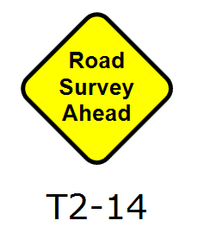

The_Fictitious_Sign_we_will_Create